**Home Assignment: 2 Fundamentals of TypeScript**

**Objective:**

Here, our aim is to be able to apply typescript concepts, compile typescript files to js files, and run it

# Practice typescript concepts

* Adding types to variable
* Adding types to functions
* Adding function with optional parameters
* Adding function with default parameters
* Adding custom types
* Using combined types

**Steps to configure the project**:

* Create a new project to add typescript code
* Open the new project in VS code
* Now open the VS code terminal and install typescript using npm
* npm  install typescript
* Check if the TypeScript compiler is installed
* tsc  -version

-    Now create a new typescript file with `.ts` extension where you will be writing your typescript code

**Now start coding**

* We have added a dummy skeleton code in a JavaScript file, which you can access from this repository (<https://github.com/testleaftrainings/Playwright_JS_Weekend_Tasks/blob/main/Homework/Week1/Day2/cw.js)>
* Now try to convert this js code into typescript and try to apply all the hints written in the comments
* Then start implementing the script as per the given flow

**Reading document:**

* How to add return type in TypeScript

<https://www.w3schools.com/typescript/typescript_functions.php>

* How to see if the array includes the given value

<https://www.w3schools.com/jsref/jsref_includes_array.asp>

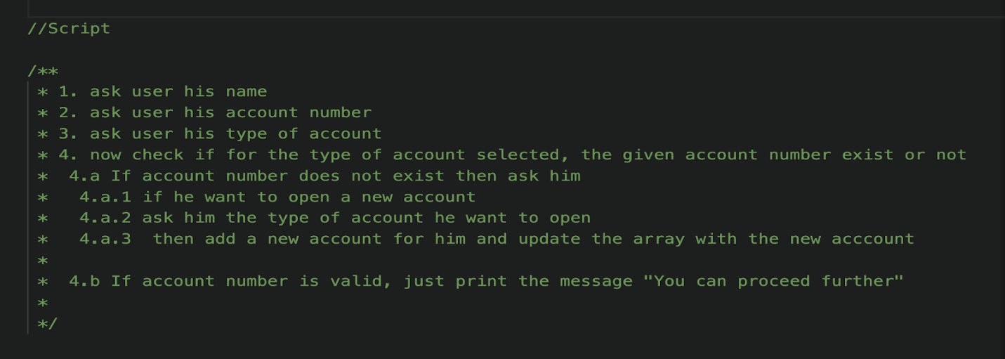

**Expected Outcome:**

Upon completion, you should be able to:

* Grasp TypeScript's core concepts, syntax, data types, and principles to create type-safe and maintainable JavaScript code for efficient automation testing